Nama = Dwi Noorlaily Zakiya

Kelas = 1f

NIM = 362155401177

1.Link Profile FCC

<https://www.freecodecamp.org/izadwi>

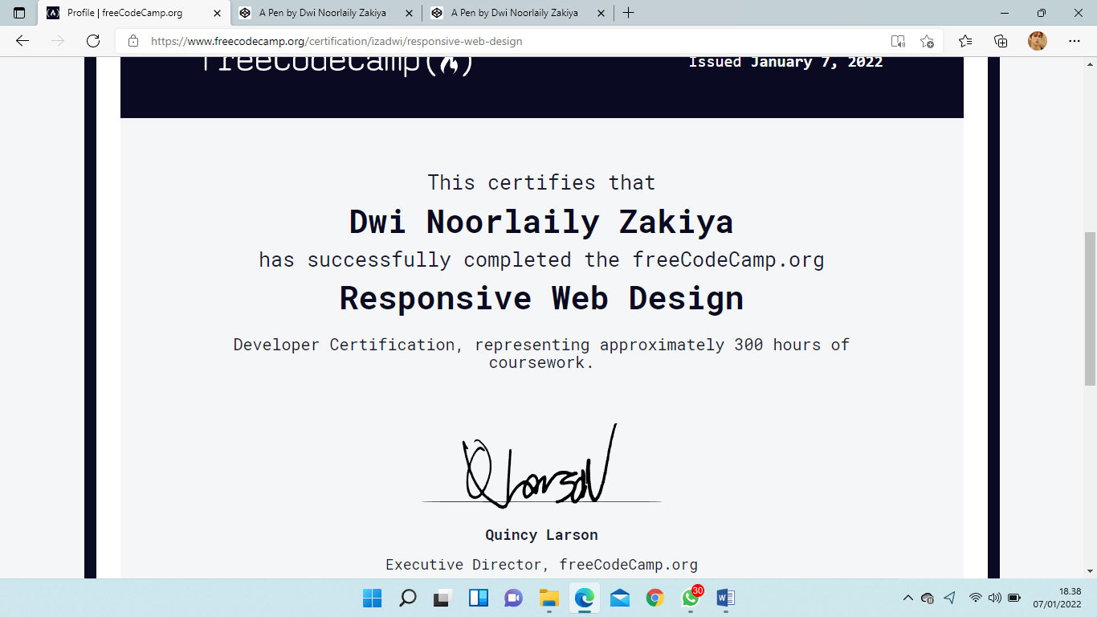2.Certification

3.Link project

1. <https://codepen.io/izzazakiya/pen/mdBKNEL>

2. <https://codepen.io/izzazakiya/pen/RwLBbam>

3. <https://codepen.io/izzazakiya/pen/yLzqVWK>